AGRICULTURE MARKET PRICE RECORDS

A Data Analysis Project Using Python

Submitted By:
Nusaira.C V
Course:
Program In AI Driven Data Analytics
Batch:
[DA55]
Academic Year:
2026
nSl. No. | Contents | Page No.
1 | Title Page | 1
2 | Index | 2
3 | Abstract | 3
4 | Introduction | 4
5 | Problem Statement | 5
6 | Project Objectives | 6
7 | Dataset Description | 7
8 | Tools and Technologies Used | 8
9 | Data Cleaning and Preprocessing | 9
10 | Exploratory Data Analysis (EDA) | 10
11 | Data Visualization | 11
12 | Key Findings and Insights | 12
13 | Recommendations | 13
14 | Conclusion | 14
15 | Limitations and Future Scope | 15
16 | References | 16

1.Abstract
The Agriculture Market Price Records project focuses on analysing agricultural commodity prices across different markets in India using Python. Agricultural market prices can vary across states, districts, markets, and commodities. Analysing these records helps identify price differences, examine price distributions, and understand variations in average modal prices across the available market records.
The project uses a dataset containing 28,268 rows and 10 columns, with information about states, districts, markets, commodities, varieties, grades, arrival dates, minimum prices, maximum prices, and modal prices. The analysis was performed using Python in Google Colab, with libraries including Pandas, NumPy, Matplotlib, Seaborn, and Plotly.
The data cleaning and preprocessing stage involved checking missing values and duplicate records, correcting data types, removing unnecessary spaces, standardising categorical values where appropriate, checking price validity, and identifying potential outliers using the Interquartile Range (IQR) method. Exploratory Data Analysis (EDA) was then performed to examine commodity prices, compare average modal prices across states, and investigate the relationship between minimum and maximum prices. Visualizations were created to present the results clearly.
The analysis included comparisons of average modal prices across commodities and states, an examination of the modal price distribution, and a comparison of average modal prices on 13 October 2026 and 16 October 2026. The average modal price was ₹5,464.88 on 13 October 2026 and ₹5,445.03 on 16 October 2026, representing a decrease of ₹19.85 between the two dates.
Overall, this project demonstrates how Python-based data cleaning, exploratory analysis, and data visualization can be used to examine agricultural market price records and communicate meaningful insights. Since the dataset covers only two dates, the date-based results represent a comparison between those dates rather than a long-term price trend.

2. Introduction
Agriculture plays an important role in the Indian economy by supporting rural livelihoods, providing employment, and contributing to the country's food supply. Agricultural commodity prices are an important factor for farmers, traders, wholesalers, retailers, and consumers. These prices can vary depending on the commodity, market location, quality, supply, demand, and other market conditions.
Understanding agricultural market prices is important because price variations across markets can influence selling decisions, purchasing costs, and market planning. Analysing market price records can help identify differences in commodity prices across states and markets, examine the distribution of prices, and understand the relationship between minimum, maximum, and modal prices.
The Agriculture Market Price Records project uses Python to analyse agricultural commodity price data collected from different markets in India. The dataset contains 28,268 records and 10 columns, including state, district, market, commodity, variety, grade, arrival date, minimum price, maximum price, and modal price. These details provide a basis for examining agricultural market prices from different perspectives.
The project involves data cleaning and preprocessing to improve data quality, followed by Exploratory Data Analysis (EDA) to identify patterns and meaningful observations. Python libraries such as Pandas and NumPy are used for data manipulation and numerical operations, while Matplotlib, Seaborn, and Plotly are used for data visualization.
The analysis includes comparisons of average modal prices across commodities and states, examination of the distribution of modal prices, investigation of the relationship between minimum and maximum prices, and comparison of average modal prices across the two available dates. Charts and statistical summaries are used to communicate the results clearly.
Overall, this project demonstrates the application of data analytics techniques to real-world agricultural market records. It aims to improve the understanding of price variations across the available markets and show how data-driven analysis can support further investigation of agricultural commodity prices in India.

3.Problem Statement
Agricultural commodity prices vary across states, districts, and markets in India. Understanding these variations is important for identifying price patterns and comparing the prices of different agricultural commodities. However, analysing raw market price data can be challenging because the dataset may contain inconsistent text values, unnecessary whitespace, and price records that require further investigation.
Therefore, this project aims to clean and analyse agricultural market price records using Python to understand price variations across commodities and states, examine price distributions, compare prices between the available dates, and investigate the relationship between minimum and maximum prices. Data visualization is used to present the findings clearly and support a better understanding of agricultural commodity price patterns.

4. Project Objectives
To analyze agricultural commodity prices across different markets in India to understand price variations between commodities, locations, and selected dates.

Specific Objectives
- To analyze agricultural commodity prices: Examine the minimum, maximum, and modal prices of different agricultural commodities.
- To compare prices across states: Identify differences in average modal prices among Indian states.
- To identify high-priced commodities: Identify commodities with the highest average modal prices and compare their price levels.
- To analyze price distributions: Examine the distribution of minimum, maximum, and modal prices and investigate unusually high price records using statistical methods.
- To compare prices across available dates: Analyze average modal prices on 13 October 2026 and 16 October 2026 to identify changes between the two dates.
- To examine relationships between prices: Analyze the relationship between minimum and maximum prices and check for inconsistencies in the recorded values.
- To improve data quality: Clean the dataset by removing unnecessary whitespace, standardizing inconsistent text values, converting dates into the appropriate format, and checking for missing values and duplicate records.
- To present findings through data visualization: Use charts and graphs to communicate price patterns, comparisons, distributions, and key findings clearly.

5. Dataset Description

5.1Overview of the Dataset
The dataset used in this project, Agriculture Market Price Records, was obtained from the Government of India's open data portal, data.gov.in. The original dataset is titled Current Daily Price of Various Commodities from Various Markets (Mandi).
Original Dataset Source: data.gov.in – Current Daily Price of Various Commodities from Various Markets (Mandi)
The dataset contains real agricultural market price records from various markets across India. It provides information about agricultural commodities, their varieties and grades, market locations, arrival dates, and minimum, maximum, and modal prices.
For this project, data from two different dates, 13 October 2026 and 16 October 2026, was downloaded from the source. The two datasets were combined row-wise into a single dataset for analysis. The resulting dataset contains 28,268 rows and 10 columns.
The combined dataset was used to study agricultural commodity price variations across states and commodities, examine price distributions, compare average modal prices between the two dates, and identify unusual price records.
The combined dataset contains the following 10 columns:
Sl. No. | Column Name | Description
1 | State | Name of the Indian state or territory where the agricultural market is located.
2 | District | Name of the district in which the market is situated.
3 | Market | Name of the agricultural market or mandi where the commodity price was recorded.
4 | Commodity | Name of the agricultural commodity being traded.
5 | Variety | Variety or type of the agricultural commodity.
6 | Grade | Quality grade of the commodity, where specified.
7 | Arrival_Date | Date associated with the agricultural market price record.
8 | Min_Price | Minimum recorded price of the commodity.
9 | Max_Price | Maximum recorded price of the commodity.
10 | Modal_Price | Modal price, representing the price at which the commodity was most commonly traded in the market.
The dataset contains three main types of information:
- Categorical data: State, District, Market, Commodity, Variety, and Grade. These columns describe the locations and characteristics of the agricultural commodities.
- Date data: Arrival_Date, which identifies the date associated with each price record.
- Numerical data: Min_Price, Max_Price, and Modal_Price, which contain the recorded agricultural commodity prices.

6. Tools and Technologies Used
The Agriculture Market Price Records project was carried out using Python and its data analysis libraries in Google Colab. These tools were used to clean and preprocess the dataset, perform Exploratory Data Analysis (EDA), calculate descriptive statistics, identify potential outliers, and create visualizations.
The following tools and technologies were used in this project.

6.1Python
Python is a programming language widely used for data analysis and data manipulation. In this project, Python was used to perform data cleaning, process the agricultural market price records, calculate statistical measures, and analyse price variations.

6.2 Google Colab
Google Colab is a cloud-based platform that allows users to write and execute Python code through a web browser. It was used as the working environment for uploading the CSV dataset, writing and executing code, analysing the data, and generating visualizations.

6.3 Pandas
Pandas is a Python library used for data manipulation and analysis. It was used to load the CSV files, combine the two datasets, inspect the data, handle text inconsistencies, convert date values, check for missing values and duplicates, and calculate descriptive statistics.

6.4 NumPy
NumPy is a Python library used for numerical operations. It supported numerical calculations and statistical analysis during the data analysis process.

6.5 Matplotlib
Matplotlib is a Python library used to create static visualizations. It was used to present agricultural price comparisons and distributions through charts and graphs.

6.6 Seaborn
Seaborn is a Python data visualization library built on Matplotlib. It was used to create statistical visualizations and help examine patterns and relationships in the agricultural price data.

6.7 Plotly
Plotly is a Python visualization library used to create interactive charts. It was used for data visualization to help present and explore agricultural market price information.

6.8 CSV File Format
CSV (Comma-Separated Values) is a file format used to store tabular data. The two downloaded datasets were in CSV format and were combined into a single dataset containing 28,268 rows and 10 columns for analysis.

7. Data Cleaning and Preprocessing
Data cleaning and preprocessing are important steps in data analysis because they help improve data quality, consistency, and reliability. In this project, Python and Pandas were used to inspect and prepare agricultural market price records collected from the Government of India's data portal. The dataset contained daily commodity price records from different agricultural markets in India for 13 October 2026 and 16 October 2026.
The following steps were performed to examine the dataset, standardize text values, validate prices and dates, investigate potential outliers, and verify the final dataset structure.

7.1 Initial Dataset Inspection
The dataset was loaded into a Pandas DataFrame and examined to understand its structure, column names, data types, and dimensions.
The initial dataset contained 28,268 rows and 10 columns. The columns represented the state, district, market, commodity, variety, grade, arrival date, minimum price, maximum price, and modal price.
The shape, columns, head(), and dtypes attributes and methods were used to inspect the dataset.

7.2 Checking Missing Values
Missing values were checked using the Pandas isnull().sum() method.
The results showed that all 10 columns contained zero missing values. Therefore, no missing-value imputation or deletion was required.

7.3 Checking Duplicate Records
Duplicate rows were checked using the duplicated().sum() method.
The result was zero completely duplicated rows. Therefore, no records were removed through duplicate-row deletion.

7.4 Removing Unnecessary Whitespace
Leading and trailing whitespace was removed from the categorical columns: State, District, Market, Commodity, Variety, and Grade.
Repeated whitespace within text values was also standardized to a single space. Before this correction, 23 district entries and 1,190 market entries were identified as containing extra whitespace.
This step improved text consistency and helped prevent unnecessary differences between category labels.

7.5 Checking and Standardizing Categorical Values
The unique values in the categorical columns were examined to identify possible inconsistencies. Capitalization checks did not identify capitalization differences in the examined columns. Additional checks identified variations involving punctuation, spacing, and spelling.
Selected corrections were made after reviewing the relevant values. For example, AJattihalli(Uzhavar Sandhai ) was standardized to A.Jattihalli(Uzhavar Sandhai ), and the repeated-space version of Ashta APMC was standardized to Ashta APMC.
Selected variety labels were also corrected, including I.R.-64 to I.R. 64, Bangalore-Samall to Bangalore-Small, and Bengal Deshi (A) FIne to Bengal Desh (A) Fine. The label Malbar was replaced with Malabar based on the correction applied during the cleaning process.
Not all similar-looking labels were automatically merged. Values such as F.A.Q. and F.A.Q, or Ground Nut Seed and Groundnut seed, were retained separately where the available information did not establish that they represented the same category. This helped avoid making unsupported assumptions about the original data.

7.6 Checking Numerical Columns and Data Types
The data types of the three price columns were examined. The minimum, maximum, and modal price columns were stored as numerical float64 values.
A numeric-conversion check identified zero non-numeric values in each price column. Therefore, no additional conversion of price values was required.
The Arrival_Date column was stored in the datetime64[ns] format, allowing date-based comparisons and analysis.

7.7 Checking Negative and Zero Prices
The three price columns were checked for negative and exactly zero values.
The results showed:
- Min_Price: zero negative values and zero exactly zero values.
- Max_Price: zero negative values and zero exactly zero values.
- Modal_Price: zero negative values and zero exactly zero values.
Although no negative or exactly zero prices were found, some records contained values below 1. These records were investigated separately.

7.8 Checking Unusually Low Prices
Records containing a value below 1 in any of the three price columns were identified for further review.
The analysis found 16 affected records, all associated with Patti APMC in Tarntaran district, Punjab. Nine records belonged to 13 October 2026, and seven belonged to 16 October 2026. Most of these records contained prices of 0.01, while two Banana records contained prices of 0.15 and 0.12.
These values were flagged because they were unusually low compared with the other recorded prices. However, they were not automatically treated as errors or removed. Further verification against the original data source is necessary before deciding whether any correction is appropriate.

7.9 Validating Arrival Dates
The arrival-date column was checked for missing dates, invalid date values, and inconsistent date formats.
The checks identified zero missing dates and zero invalid dates. The dataset contained two unique arrival dates:
- 13 October 2026
- 16 October 2026
The date values were stored in a consistent date format, and the column was available for date-based analysis.

7.10 Validating Price Relationships
The relationship between minimum, modal, and maximum prices was checked to identify records where:
- The minimum price exceeded the maximum price.
- The modal price was below the minimum price.
- The modal price exceeded the maximum price.
The validation identified zero records with invalid price relationships. All records satisfied the checked condition:
Min_Price ≤ Modal_Price ≤ Max_Price
This confirmed that no violations of these price-ordering rules were found in the dataset.

7.11 Descriptive Statistics of Numerical Columns
The Pandas describe() method was used to calculate descriptive statistics for the three price columns.
The results were:
Statistic | Min_Price | Max_Price | Modal_Price
Count | 28,268 | 28,268 | 28,268
Mean | 5,006.37 | 5,866.14 | 5,456.01
Standard deviation | 5,422.43 | 6,575.35 | 5,933.82
Minimum | 0.01 | 0.01 | 0.01
25th percentile | 2,500 | 3,000 | 2,650
Median | 3,800 | 4,400 | 4,000
75th percentile | 6,000 | 6,972 | 6,500
Maximum | 220,000 | 410,000 | 315,000
The statistics showed considerable variation in the recorded commodity prices. The high maximum values and relatively large standard deviations indicated that some prices were substantially higher than the central values of the dataset.

7.12 Detecting Potential Outliers Using the IQR Method
The Interquartile Range (IQR) method was used to identify potential outliers in the three price columns.
The IQR was calculated as the difference between the third quartile (Q3) and the first quartile (Q1). Values outside the lower and upper IQR boundaries were flagged for investigation.
Price column | Q1 | Q3 | IQR | Upper bound | Potential outliers
Min_Price | 2,500 | 6,000 | 3,500 | 11,250 | 1,701
Max_Price | 3,000 | 6,972 | 3,972 | 12,930 | 1,967
Modal_Price | 2,650 | 6,500 | 3,850 | 12,275 | 1,782
Examples of high-priced records included cardamom, mentha oil, cashewnuts, and walnuts. Such values were investigated as potential outliers rather than automatically classified as errors because different commodities may have substantially different price levels.
The flagged outliers were not automatically removed. This preserved potentially valid price records for further analysis.

7.13 Examining Extremely High and Low Modal Prices
The nlargest() and nsmallest() methods were used to examine the highest and lowest recorded modal prices.
The highest modal price in the displayed results was 315,000 for cardamom at APMC Mumbai, Maharashtra, on 16 October 2026. Other high-priced records included mentha oil, cashewnuts, tube flower, almond, kakada, and jasmine.
The lowest modal prices were 0.01, found among several commodities recorded at Patti APMC, Punjab. These low values were already identified in the earlier investigation of prices below 1.
This examination helped identify extreme values that may require verification against the original source.

7.14 Summarizing Commodity Prices
A grouped summary was generated using the commodity column and the three price columns. Minimum, maximum, and mean values were calculated for each commodity.
This summary helped examine differences in price levels among commodities and provided an initial overview for the exploratory data analysis stage.

7.15 Comparing Average Modal Prices by Date
A pivot table was created to compare average modal prices for each commodity on 13 October 2026 and 16 October 2026.
The analysis showed that average prices differed between the two dates for some commodities. For example, the average modal price of Almond (Badam) increased from 97,500 to 102,500, while the average for Arecanut (Betelnut/Supari) decreased from approximately 34,311.19 to 30,672.45.
Some commodities had no records on one of the dates. These were represented by missing values in the pivot table and could not be compared directly across both dates.

7.16 Comparing Record Counts by Commodity and Date
A second pivot table was created to count the available modal-price records for each commodity on each date.
The results showed that record counts differed across commodities and between the two dates. For example, Amaranthus had 204 records on 13 October and 195 on 16 October, while Apple had 162 and 127 records, respectively.
These differences are important when interpreting average modal prices because the averages may be based on different numbers of observations and different market records.

7.17 Final Data Quality Validation
A final validation check was performed to verify the dataset dimensions, column names, missing values, duplicate rows, data types, blank categorical values, negative prices, price relationships, arrival dates, and unusually low prices.
The final dataset contained 28,268 rows and 10 columns. The checks identified:
- Zero missing values.
- Zero completely duplicated rows.
- Zero blank categorical values in the six checked categorical columns.
- Zero negative price values.
- Zero records violating the checked price relationships.
- Zero missing arrival dates.
- Two unique arrival dates.
- Sixteen records with prices below 1 requiring further verification.
The final row-indexing step changed the DataFrame index to begin at 1. The three price columns were then renamed from Min_x0020_Price, Max_x0020_Price, and Modal_x0020_Price to Min_Price, Max_Price, and Modal_Price, respectively, to improve readability and simplify subsequent coding.
The updated column names were verified after renaming. The operation changed the column labels but did not alter the price values or the dataset dimensions.

8. Exploratory Data Analysis (EDA)
Exploratory Data Analysis (EDA) was performed on the agricultural market price dataset to identify patterns, variations, relationships, and important insights in the recorded commodity prices. Python and the Pandas library were used to summarize the data and compare prices across commodities, states, markets, and available dates.
The analysis began with descriptive statistics for the minimum, maximum, and modal prices. The dataset contained 28,268 records and 10 columns, covering 256 unique commodities. The average modal price was 5,456.01, while the median modal price was 4,000.00, indicating variation in the recorded prices.
Commodity-wise analysis was conducted to identify commodities with the highest and lowest average modal prices. Cardamom had the highest average modal price at 315,000.00, while Lotus had the lowest average among the ten commodities with the lowest averages, at 8.00. The number of records for each commodity was also examined because some averages were based on very few observations.
State-wise and market-wise analyses were performed to compare average modal prices across different locations. Manipur had the highest average modal price among the ten selected states, at 10,020.41, while Banthara APMC had the highest average among the ten selected markets, at 135,000.00. Record counts were examined alongside state-wise averages to understand how much data supported each comparison. Tamil Nadu had 13,750 records among the selected states, whereas Andaman and Nicobar had only 23.
The analysis also compared average modal prices across the two available dates, 13 October 2026 and 16 October 2026. The average decreased from 5,464.88 to 5,445.03, a difference of approximately 19.85. Since only two dates were available, this comparison was not treated as a long-term trend.
The highest and lowest individual modal-price records were examined to identify unusual values. The highest recorded modal price was 315,000.00, while several records had a modal price of 0.01. These unusual values were identified for further verification rather than automatically classified as errors. The relationship between minimum, modal, and maximum prices was also checked to assess consistency in the recorded price values.
Overall, EDA helped reveal differences in agricultural commodity prices across commodities, states, markets, and dates. It also highlighted the importance of considering record counts and investigating unusual values before drawing conclusions. The findings provide a foundation for presenting the results through charts and graphs in the data visualization section.

9. Data Visualization
Data visualization was performed using Python libraries, including Matplotlib and Seaborn, to present the findings of the agricultural market price analysis. Bar charts, histograms, a box plot, a scatter plot, a line chart, and a correlation heatmap were used to compare prices, examine distributions, identify unusual values, and understand relationships between price variables.

9.1 Top 10 Commodities by Average Modal Price
Figure 9.1: Top 10 Commodities by Average Modal Price
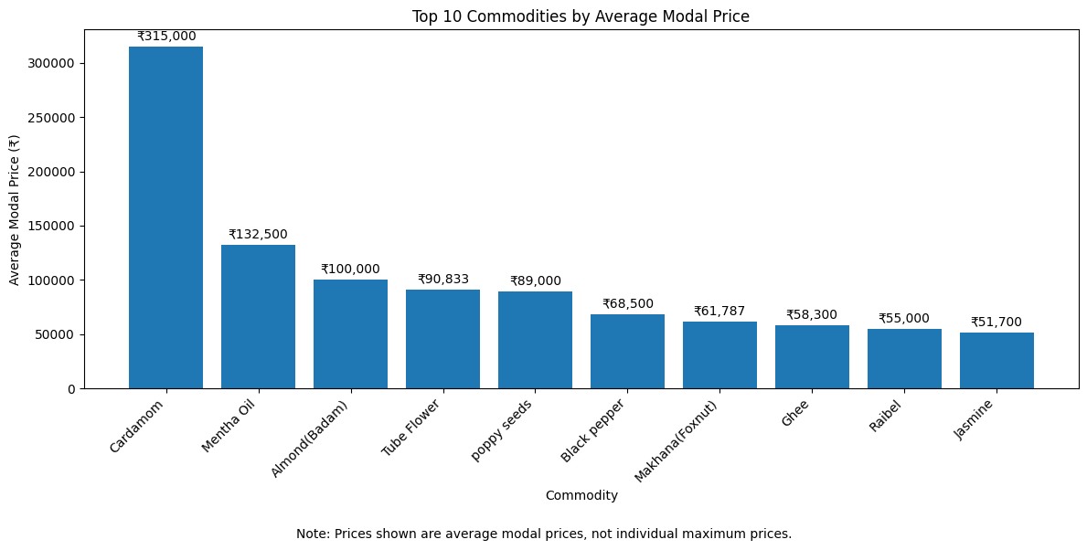Interpretation:
The bar chart compares the ten commodities with the highest average modal prices. Cardamom recorded the highest average modal price at ₹315,000, followed by Mentha Oil at ₹132,500 and Almond(Badam) at ₹100,000. Jasmine has the lowest average among these 10 commodities at 51,700.The chart highlights differences in average modal prices among the selected commodities. These values represent averages, not individual maximum prices.

9.2 Top 10 States by Average Modal Price
Figure 9.2: Top 10 States by Average Modal Price
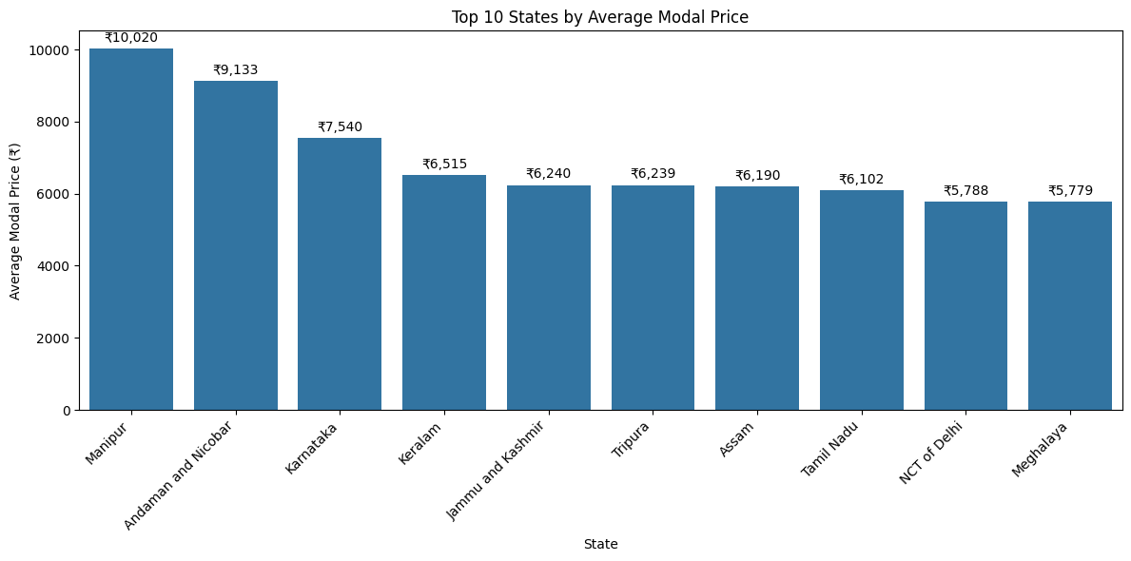Interpretation:
The chart shows that Manipur has the highest average modal price at approximately ₹10,020, followed by Andaman and Nicobar at ₹9,133, while Meghalaya has the lowest average among the top 10 locations at approximately ₹5,779. The number of records varies across locations, with 49 records for Manipur and 13,750 for Tamil Nadu, so record counts should be considered when comparing averages. These results show differences in average modal prices across locations but do not mean that every commodity is more expensive in Manipur.
9.3 Distribution of Modal Prices Figure 9.3: Distribution of Modal Prices up to ₹20,000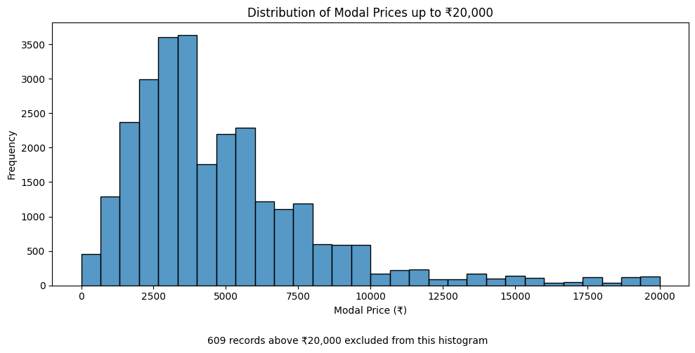
Interpretation:
The histogram shows the distribution of modal prices up to ₹20,000. Most of the displayed records are concentrated in the lower and middle price ranges, while the frequency generally decreases at higher price levels. A total of 609 records above ₹20,000 were excluded from this histogram to make the main distribution easier to examine.

9.4 Box Plot of Modal Prices
Figure 9.4: Box Plot of Modal Prices up to ₹20,000
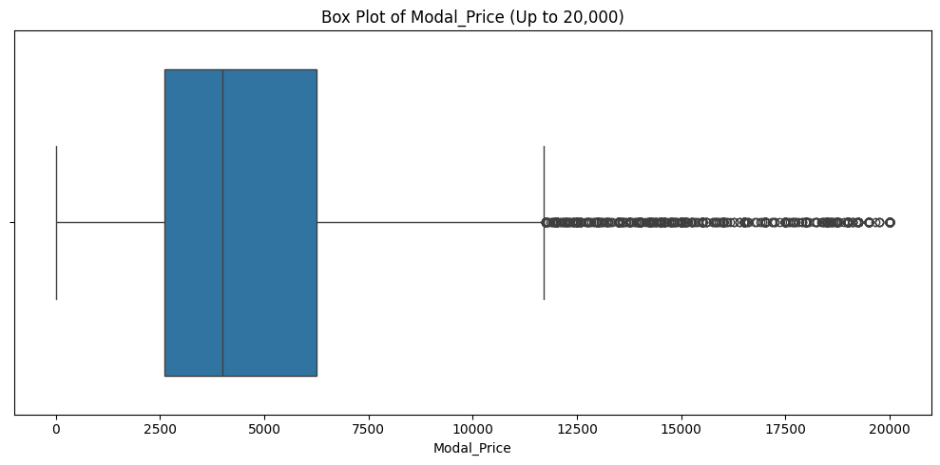Interpretation:

The box plot shows that most modal prices are between ₹2,600 and ₹6,300, with a median of approximately ₹4,000. Several unusually high prices appear as outliers, extending up to ₹20,000. The distribution is right-skewed, indicating that a few commodities have much higher prices than most others. These outliers should be checked before correcting or removing any values.

9.5 Relationship Between Minimum and Maximum Prices
Figure 9.5: Minimum Price vs Maximum Price
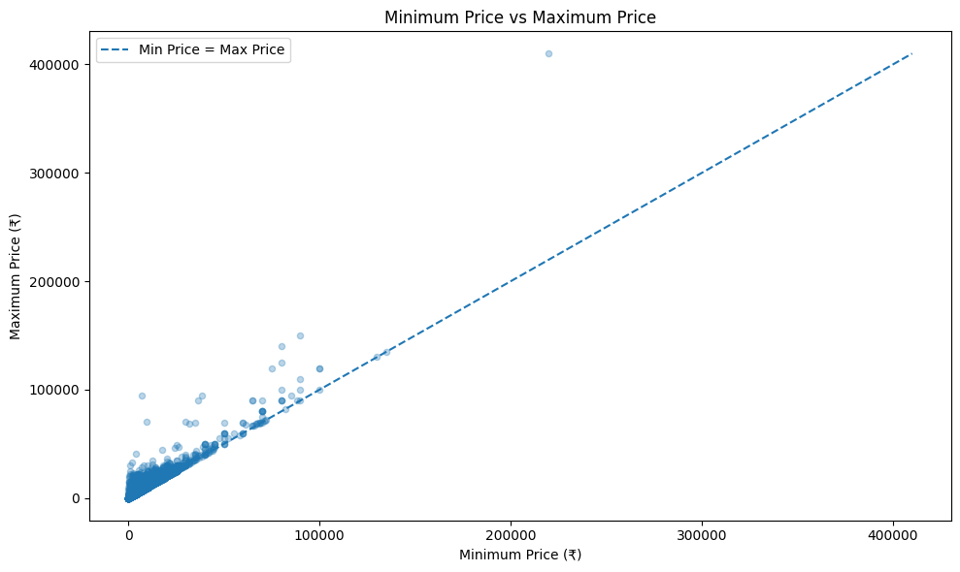Interpretation:
The scatter plot examines the relationship between minimum and maximum prices. The points generally show a positive relationship: records with higher minimum prices tend to have higher maximum prices. The dashed line represents equality between the two prices. Points above this line have maximum prices greater than minimum prices, as expected. The chart also shows a small number of observations with particularly high prices.

9.6 Comparison of Average Modal Prices Between Two Dates
Figure 9.6: Comparison of Average Modal Prices Between Two Dates
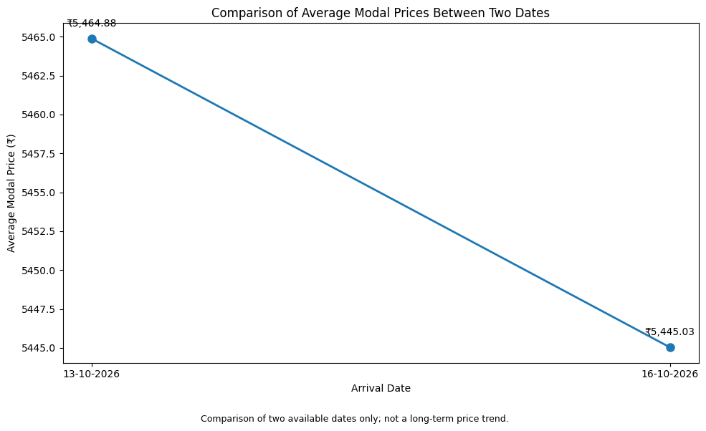Interpretation:
The line chart compares average modal prices on 13 October 2026 and 16 October 2026. The average decreased from ₹5,464.88 on 13 October to ₹5,445.03 on 16 October, a difference of approximately ₹19.85. Since only two dates are available, the result represents a comparison between these dates rather than a long-term price trend.

9.7 Correlation Between Commodity Price Variables
Figure 9.7: Correlation Heatmap of Commodity Prices
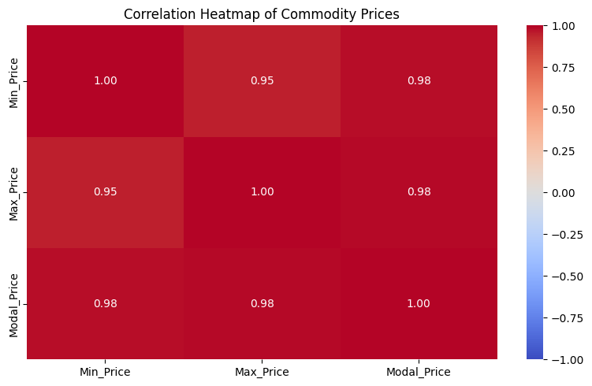Interpretation:
The values are between 0.95 and 0.98, which means all three prices have a very strong relationship. When one price increases, the other prices generally increase too.
The value 1.00 on the diagonal means each price is perfectly related to itself.

9.8 Top Markets by Average Modal Price of Bitter Gourd
Figure 9.8: Top Markets by Average Modal Price of Bitter Gourd
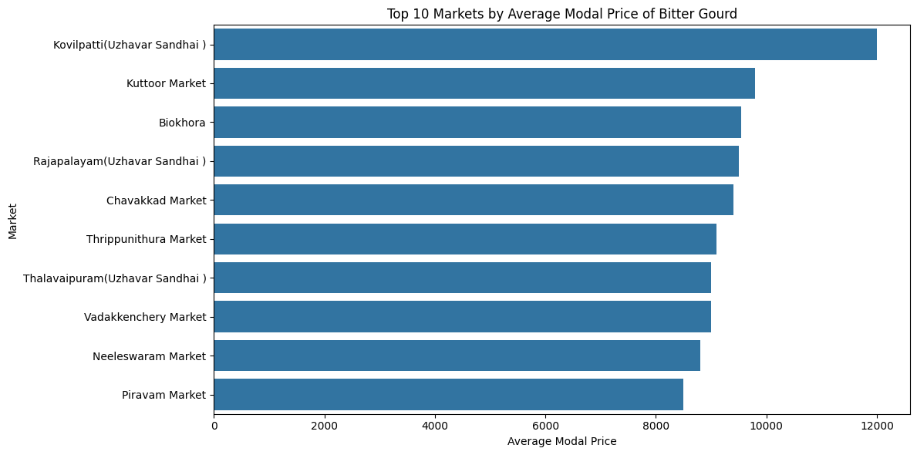Interpretation:
The horizontal bar chart compares markets based on the average modal price of Bitter Gourd. Kovilpatti (Uzhavar Sandhai) recorded the highest average at approximately ₹12,000, followed by Kuttoor Market at approximately ₹9,800. The chart helps identify differences in average Bitter Gourd prices across the displayed markets.

10. Key Findings and Insights
The analysis of agricultural market price records revealed the following important findings:
- Dataset Coverage: The dataset contained 28,268 records and 10 columns, covering 256 unique commodities across different agricultural markets.
- Highest Average Commodity Price: Cardamom recorded the highest average modal price at ₹315,000, followed by Mentha Oil at ₹132,500 and Almond(Badam) at ₹100,000.
- Lowest Average Commodity Price: Lotus had the lowest average modal price among the ten lowest-ranked commodities, at ₹8.
- State-wise Price Comparison: Manipur recorded the highest average modal price among the ten selected states, at ₹10,020.41, followed by Andaman and Nicobar at ₹9,133.39.
- Market-wise Price Comparison: Banthara APMC recorded the highest average modal price among the ten selected markets, at ₹135,000.
- Price Comparison Between Dates: The average modal price decreased from ₹5,464.88 on 13 October 2026 to ₹5,445.03 on 16 October 2026, a difference of approximately ₹19.85.
- Frequently Recorded Commodities: Tomato was the most frequently recorded commodity, with 976 records, followed by Brinjal with 945 records and Onion with 899 records.
- Price Distribution and Outliers: The histogram and box plot showed that most modal prices were concentrated in the lower price ranges, with some unusually high values. These values require investigation but are not necessarily errors.
- Relationship Between Prices: The correlation heatmap showed strong positive correlations between minimum and maximum prices (0.95), minimum and modal prices (0.98), and maximum and modal prices (0.98).
- Market-wise Bitter Gourd Prices: Kovilpatti (Uzhavar Sandhai) recorded the highest average modal price for Bitter Gourd among the ten markets shown, at approximately ₹12,000.

11. Recommendations
Based on the findings of the agricultural market price analysis, the following recommendations are suggested:
- Monitor Price Variations: Regularly monitor agricultural commodity prices across states and markets to understand price differences and changing market conditions.
- Verify Unusual Prices: Investigate unusually high and low price records, especially the records with a modal price of ₹0.01, before using them for further analysis.
- Consider Record Counts: Compare average prices alongside the number of records available for each state, market, and commodity to avoid misleading conclusions from limited observations.
- Improve Data Quality: Standardize commodity and market names and verify inconsistent or unusual entries to improve the reliability of future analysis.
- Use More Dates: Collect price data over a longer period to identify seasonal patterns and understand whether price changes are temporary or persistent.
- Compare Similar Commodities: For a more meaningful comparison between states and markets, analyze the same commodities and varieties across locations wherever possible.
These recommendations can help improve the reliability of agricultural price analysis and support better understanding of market price variations.

12. Conclusion
This project analyzed agricultural market price records using Python, Pandas, NumPy, Matplotlib, and Seaborn. The dataset contained 28,268 records and 10 columns, covering 256 unique commodities.
The analysis examined descriptive statistics, commodity-wise prices, state-wise and market-wise averages, price distributions, and relationships between minimum, maximum, and modal prices. Cardamom recorded the highest average modal price among the analyzed commodities, while Manipur had the highest average among the selected states. The correlation analysis also revealed strong positive relationships between the three price variables.
Data cleaning and exploratory data analysis helped identify unusual price records and important patterns in the dataset. The visualizations presented these findings clearly and made comparisons easier to understand. The project achieved its main objectives by examining price variations and demonstrating how Python-based data analysis can be used to explore agricultural market data.

13. Limitations and Future Scope
Limitations
- The dataset contains records for only two dates, 13 October 2026 and 16 October 2026, which limits the ability to identify long-term trends or seasonal patterns.
- The number of records varies considerably across states, markets, and commodities, which may affect the reliability of some average-price comparisons.
- Some unusually high and low price values require further verification against the original data source.
- The analysis focuses on recorded prices and does not include additional factors such as transportation costs, weather conditions, supply, demand, or production levels.
Future Scope
- Include data from a longer period to study seasonal variations and long-term price trends.
- Compare the same commodities across different states and markets for more meaningful comparisons.
- Investigate unusual price records using additional source information.
- Incorporate weather, production, supply, and demand data to explore factors that may influence agricultural prices.
- Develop interactive dashboards using Plotly or other visualization tools to make the findings easier to explore.
- Apply time-series analysis or forecasting methods when sufficient historical data becomes available.
These improvements could provide a more comprehensive understanding of agricultural market price patterns and their influencing factors.

14. References
- Dataset: Government of India, Current Daily Price of Various Commodities from Various Markets (Mandi). Available at: https://www.data.gov.in/resource/current-daily-price-various-commodities-various-markets-mandi
- Pandas Documentation: https://pandas.pydata.org/docs/
- NumPy Documentation: https://numpy.org/doc/
- Matplotlib Documentation: https://matplotlib.org/stable/
- Seaborn Documentation: https://seaborn.pydata.org/
- Google Colab: https://colab.research.google.com/

